Why is VNC Console (VncViewer) being blocked by Java?
Starting with Java 7 Update 51, your default Java Security Settings don’t allow applications that are not signed (Unsigned), Self-signed (not signed by trusted authority) and/or missing permission attributes. Because of this enhanced security, VNC Console VncViewer Java app gets blocked with this error:
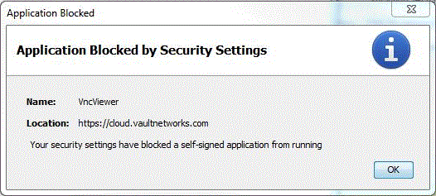

How-To Fix:
- Click on your Windows “Start” logo 
- Type “configure java” to open your Java Control Panel
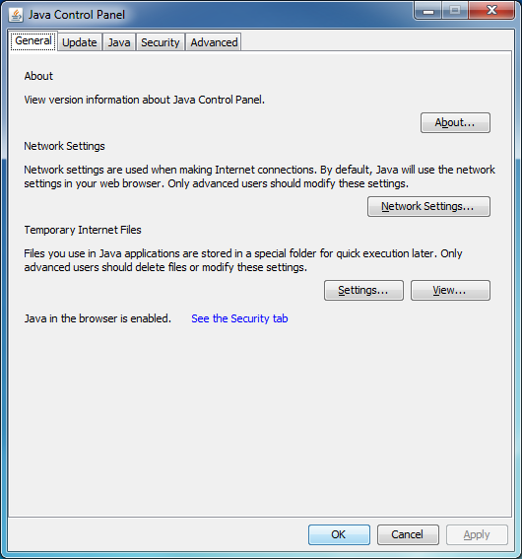
- Under Security tab, edit your Site List and add https://cloud.vaultnetworks.com
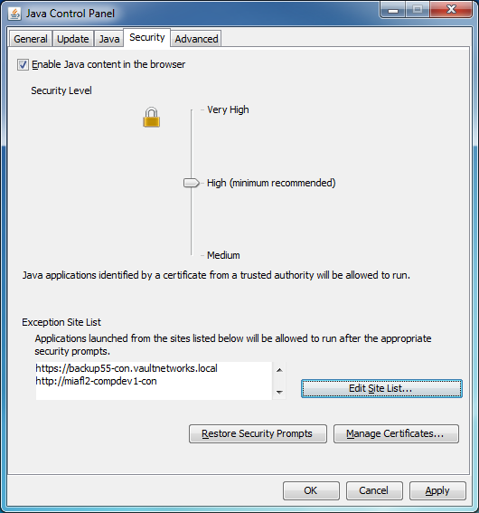
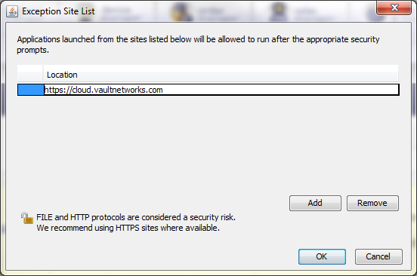
- Apply/Save these new security settings which will allow VNC-Console/VncViewer to run.

For more information or this or other Java problems, please refer to http://www.java.com/en/download/help/java_blocked.xml

